ASTRA INTERIORS
Mr. Manoker - 4 wardrobes - CARPENTER LIST
- All sizes are CUT sizes in mm (edge tape already deducted).
- Box: 2000 high, 500 deep. Loft above = 90 mm frame only (uprights + top/bottom rails).
- Sides, top, bottom and full partitions 500 (cut 499). Inside partitions 494 (cut 493). Shelves 474 (cut 473), set back 20 mm.
- Back panel 6 mm in 6 mm groove on sides, full partitions, top and bottom (size = opening + 12).
- Drawers: 2 bottom drawers per bedroom, opening 173, box 150 high, 450 soft-close channel (13 mm each side). Drawer bottom groove: leave 12 mm from bottom, 8 mm wide x 10 mm deep.
- LED profile groove: 12 W x 8 D, 100 mm from the FRONT edge, vertical, on panel face inside the section. 10 mm wire hole through top panel.
- Shutters: 18 mm ply, colour laminate outside, backer inside, 2 mm edge tape 4 sides.
- GAPS: 2 mm between doors | 3 mm+ next to side cover / strip | 2 mm cupboard door to loft door | 1 mm bottom and top.
- Side cover (518 deep = 500 + door, full height, 2 pieces joined at 2000) on ONE side; 100 mm strip on the other side. 2 mm tape on front edge only.
- Skirting 80 high, 0.5 mm tape on top edge.
- Carcass laminate: 27111 LV Ivory White (both faces). 6 mm: Ivory White one face.

Bedroom | Total width | Height | Side cover | Colours (main + accent)
GF BEDROOM | 2562 (box 2526) | 2857 | left side | 27173 LV Seaglass + 21125 Sunburn
1ST FLOOR M.BEDROOM | 2385 (box 2349) | 2905 | left side | 27292 LV Mink + 27262 LV Peacock
1ST FLOOR BEDROOM 2 | 2355 (box 2319) | 2895 | right side | 21433 SF Neo Banana Leaf + 21457 SF Aspen Gold
2ND FLOOR BEDROOM | 2385 (box 2349) | 2825 | left side | 21462 SF Lavendura + 21452 SF Prism Violet

GF BEDROOM - 2D
Box 2526 W x 2857 H x 500 D | with side cover (left) + 100 strip = 2562 W
2D drawing - inside, measurements
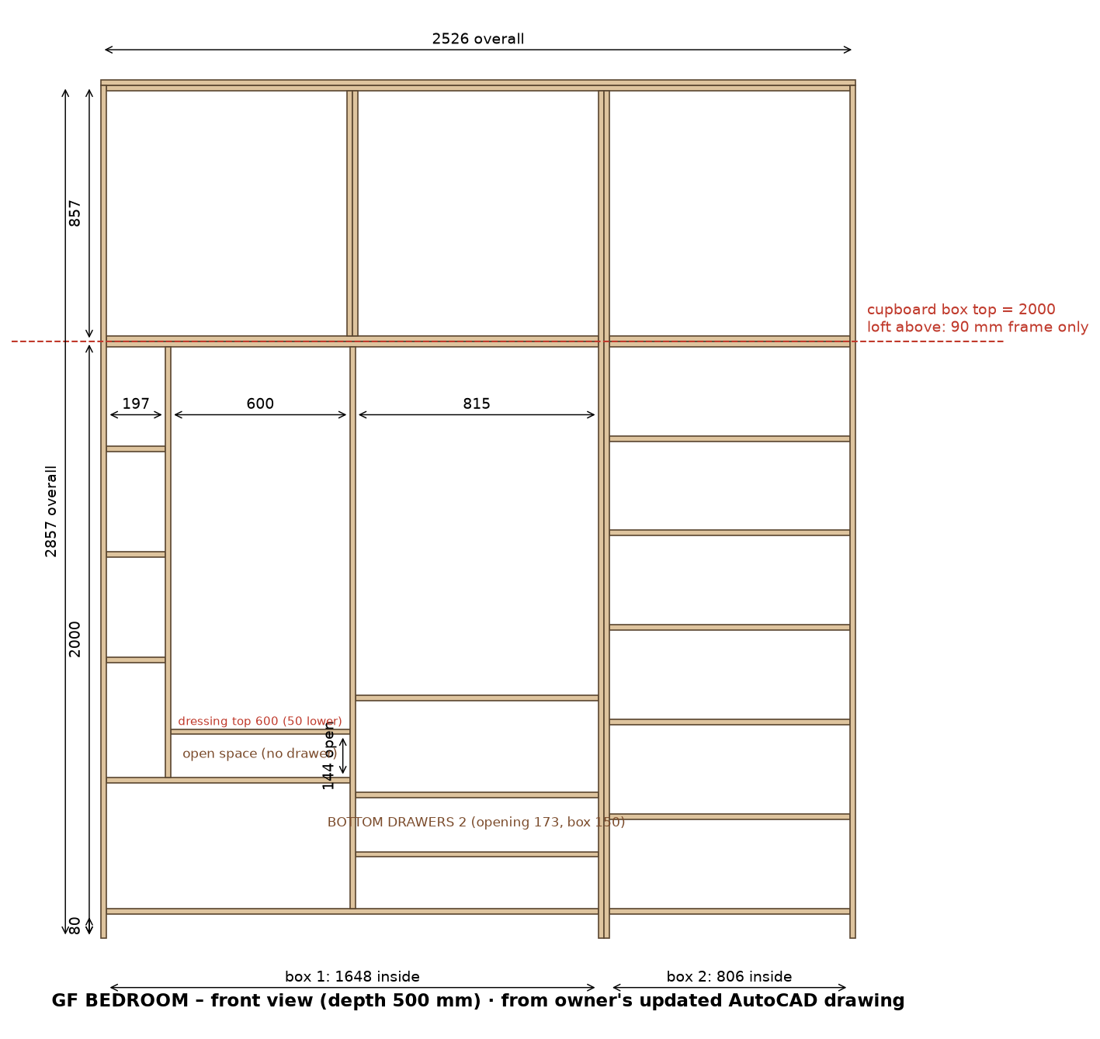
2D shutters - laminate code and size on each door
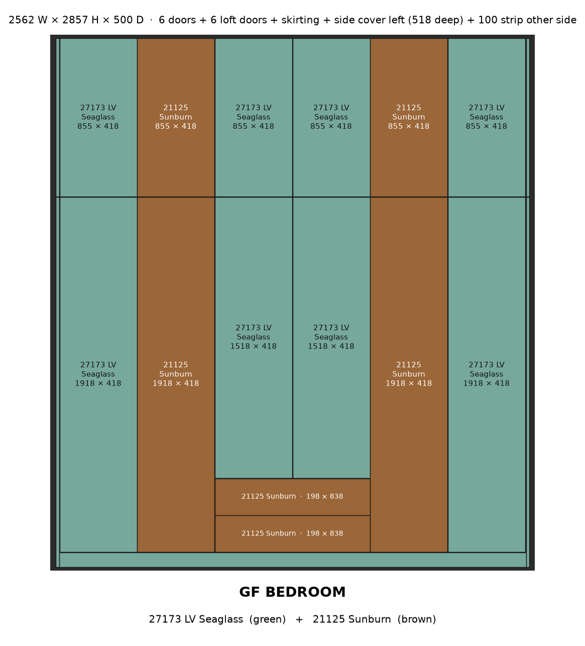

GF BEDROOM - 3D
3D - assembled box, without doors
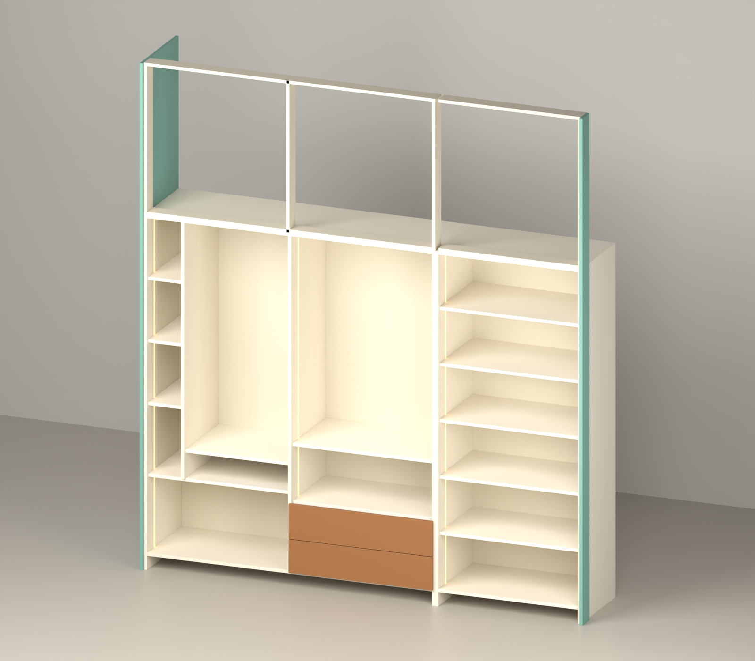
3D - exploded pieces
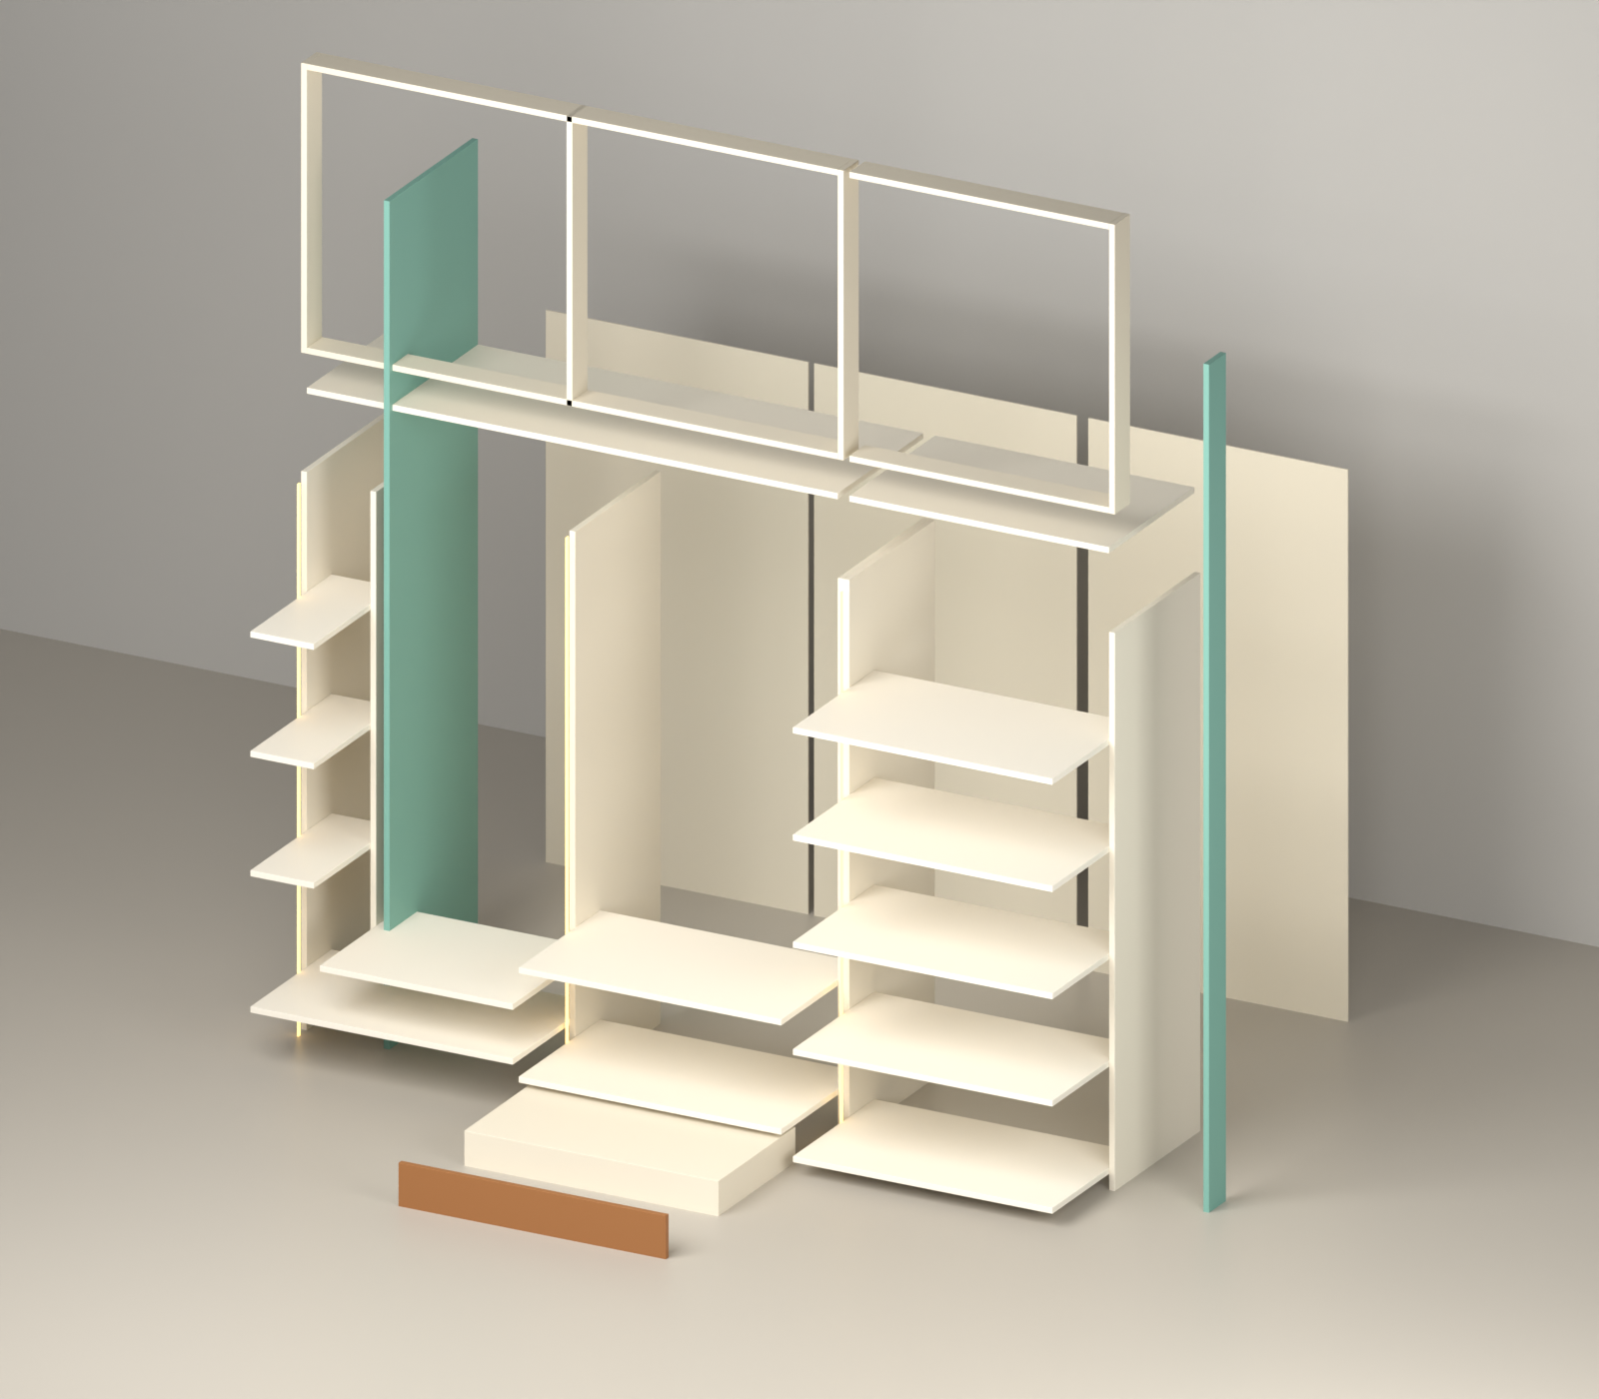

GF BEDROOM - cut list
No | Part | Laminate | Qty | Cut L | Cut W | Edge tape | Where / fitting
CARCASS (18 mm, Ivory White)
1 | Side panel (cupboard, 2000 high) | Ivory White | 4 | 2000 | 499 | 0.5 mm, 1 long | box ends; 6 mm back groove inner face; LED groove (see below)
2 | Partition (full height, doors fixed) | Ivory White | 1 | 1884 | 499 | 0.5 mm, 1 long | between sections, doors hinge here; back groove both faces
3 | Bottom panel | Ivory White | 1 | 1648 | 499 | 0.5 mm, 1 long | box bottom
4 | Top panel | Ivory White | 1 | 1648 | 499 | 0.5 mm, 1 long | box top
5 | Partition (inside) | Ivory White | 1 | 1444 | 493 | 0.5 mm, 1 long | dressing / bangle column (stands on shelf, in front of back panel)
6 | Bottom panel | Ivory White | 1 | 806 | 499 | 0.5 mm, 1 long | box bottom
7 | Top panel | Ivory White | 1 | 806 | 499 | 0.5 mm, 1 long | box top
LOFT FRAME 90 mm
8 | Top rail | Ivory White | 1 | 1648 | 89 | 0.5 mm, 1 long | loft frame top, fix to ceiling
9 | Bottom rail (front, on cupboard top) | Ivory White | 1 | 1648 | 89 | 0.5 mm, 1 long | loft frame bottom, on cupboard top
10 | Frame upright (end / partition) | Ivory White | 4 | 857 | 89 | 0.5 mm, 1 long | loft frame - at ends and partitions
11 | Top rail | Ivory White | 1 | 806 | 89 | 0.5 mm, 1 long | loft frame top, fix to ceiling
12 | Bottom rail (front, on cupboard top) | Ivory White | 1 | 806 | 89 | 0.5 mm, 1 long | loft frame bottom, on cupboard top
SHELVES
13 | Shelf | Ivory White | 4 | 815 | 473 | 0.5 mm, 1 long | set back 20 mm from front
14 | Shelf | Ivory White | 5 | 806 | 473 | 0.5 mm, 1 long | set back 20 mm from front
15 | Shelf | Ivory White | 1 | 600 | 473 | 0.5 mm, 1 long | set back 20 mm from front
16 | Shelf | Ivory White | 3 | 197 | 473 | 0.5 mm, 1 long | set back 20 mm from front
BACK PANELS 6 mm
17 | Main back panel | Ivory White 1 side | 2 | 1896 | 827 | - | slides in 6 mm groove (sides / partitions / top / bottom)
18 | Main back panel | Ivory White 1 side | 1 | 1896 | 818 | - | slides in 6 mm groove (sides / partitions / top / bottom)
DRAWER BOX
19 | drawer front/back inner | Ivory White | 4 | 753 | 149 | 0.5 mm, 1 long | groove for bottom: leave 12, 8 W x 10 D
20 | drawer side | Ivory White | 4 | 450 | 149 | 0.5 mm, 1 long | groove for bottom: leave 12, 8 W x 10 D
21 | drawer bottom 6 mm (in groove) | Ivory White 1 side | 2 | 432 | 771 | - | slides in the 10 mm groove
SHUTTERS / COVER / SKIRTING (colour laminate + backer)
22 | Side cover panel - lower (floor to 2000) | 27173 LV Seaglass | 1 | 2000 | 516 | 2 mm, 1 long | LEFT end, 518 deep (flush with door front); joint at 2000
23 | Wall-side strip 100 - lower (floor to 2000) | 27173 LV Seaglass | 1 | 2000 | 98 | 2 mm, 1 long | RIGHT end at front, flush with doors; joint at 2000
24 | Door (full height) | 27173 LV Seaglass | 2 | 1914 | 414 | 2 mm, 4 sides | 5 hinges each
25 | Door (full height) | 21125 Sunburn | 2 | 1914 | 414 | 2 mm, 4 sides | 5 hinges each
26 | Skirting (front, base 80) | 27173 LV Seaglass | 1 | 1684 | 79 | 0.5 mm, 1 long | front of base 80
27 | Door above drawers | 27173 LV Seaglass | 2 | 1514 | 414 | 2 mm, 4 sides | doors above the drawers; 4 hinges
28 | Side cover panel - upper (loft) | 27173 LV Seaglass | 1 | 857 | 516 | 2 mm, 1 long | LEFT end, 518 deep (flush with door front); joint at 2000
29 | Wall-side strip 100 - upper (loft) | 27173 LV Seaglass | 1 | 857 | 98 | 2 mm, 1 long | RIGHT end at front, flush with doors; joint at 2000
30 | Loft door | 27173 LV Seaglass | 4 | 851 | 414 | 2 mm, 4 sides | on loft frame; same width as door below
31 | Loft door | 21125 Sunburn | 2 | 851 | 414 | 2 mm, 4 sides | on loft frame; same width as door below
32 | Skirting (front, base 80) | 27173 LV Seaglass | 1 | 842 | 79 | 0.5 mm, 1 long | front of base 80
33 | Drawer outside front | 21125 Sunburn | 2 | 834 | 194 | 2 mm, 4 sides | screw to drawer box front; handle

Hardware
- LED strip light + aluminium profile (in grooves): 3 pcs, 5.22 m total
- LED driver + door sensor switch: 1
- Soft-close telescopic channels 450 mm (pairs): 2
- Drawer handles / profile: 2
- Concealed soft-close hinges (doors): 40
- Door handles: 6
LED groove (12 W x 8 D, 100 mm from front)
- Section 1 (815 wide): Side panel, right face - start 0 mm, groove 1884 mm, LED strip 1864 mm
- Section 2 (815 wide): Partition, right face - start 373 mm, groove 1511 mm, LED strip 1491 mm
- Section 3 (806 wide): Side panel, right face - start 0 mm, groove 1884 mm, LED strip 1864 mm

1ST FLOOR M.BEDROOM - 2D
Box 2349 W x 2905 H x 500 D | with side cover (left) + 100 strip = 2385 W
2D drawing - inside, measurements
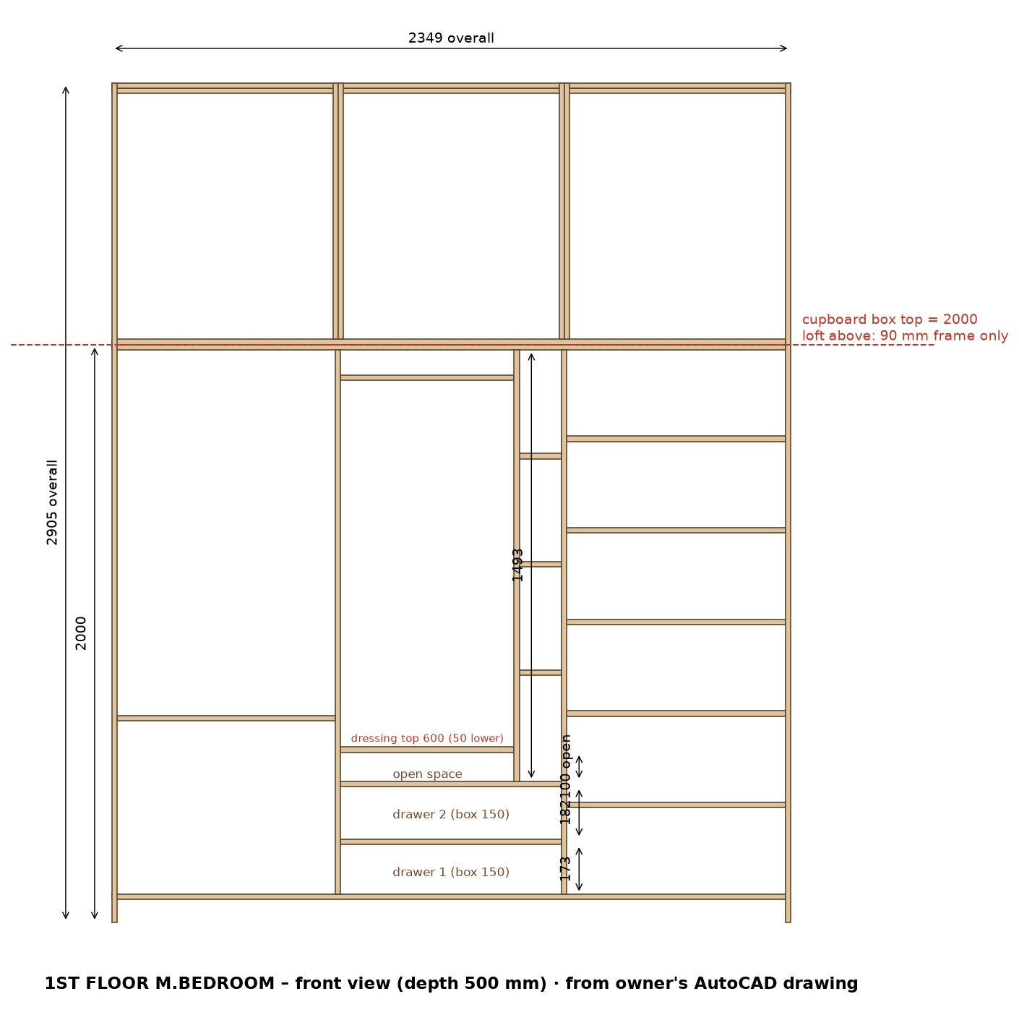
2D shutters - laminate code and size on each door
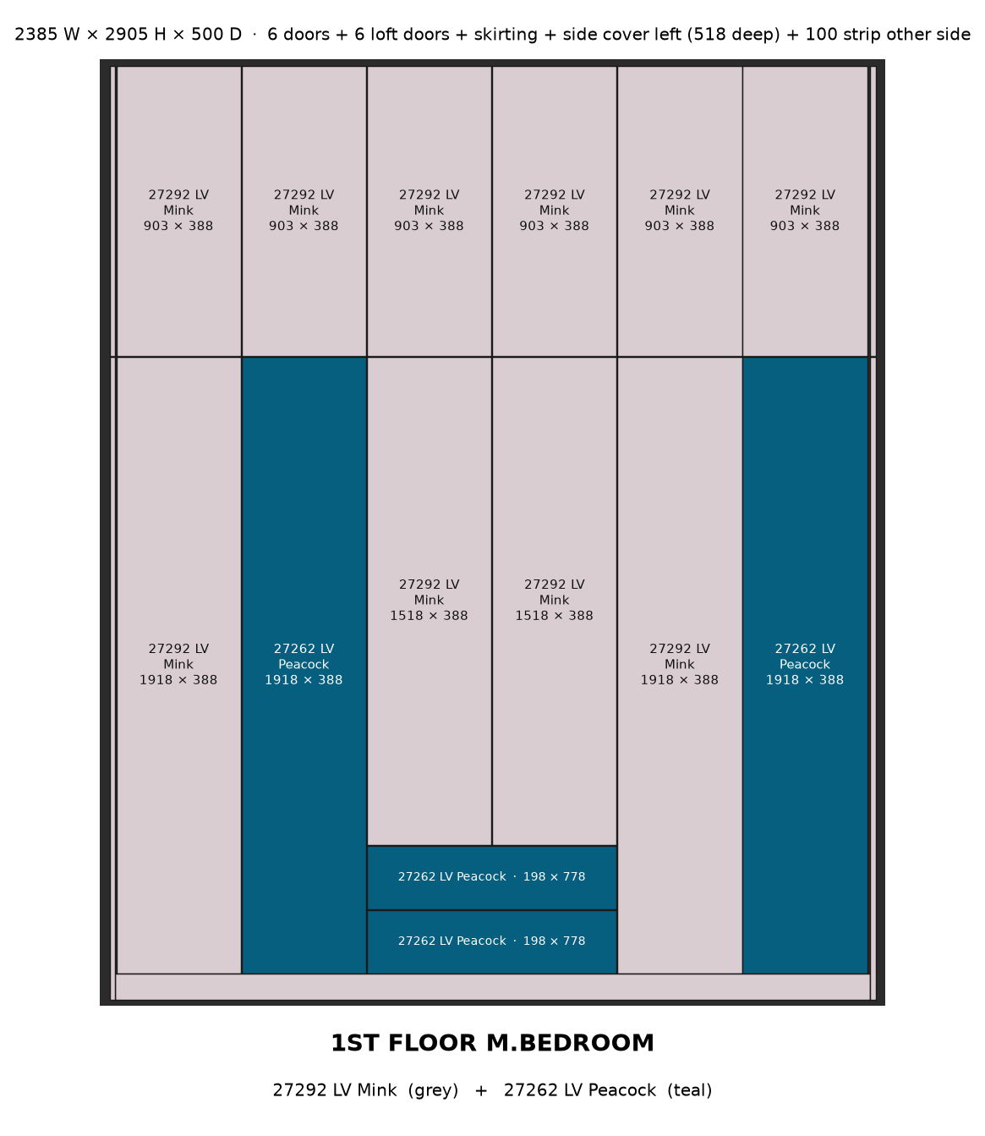

1ST FLOOR M.BEDROOM - 3D
3D - assembled box, without doors
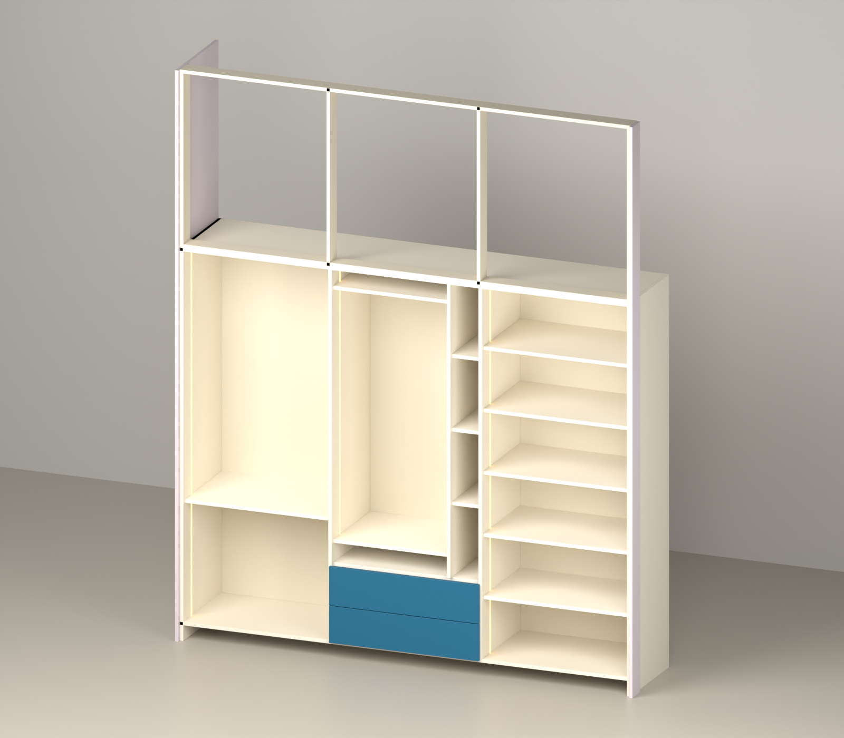
3D - exploded pieces
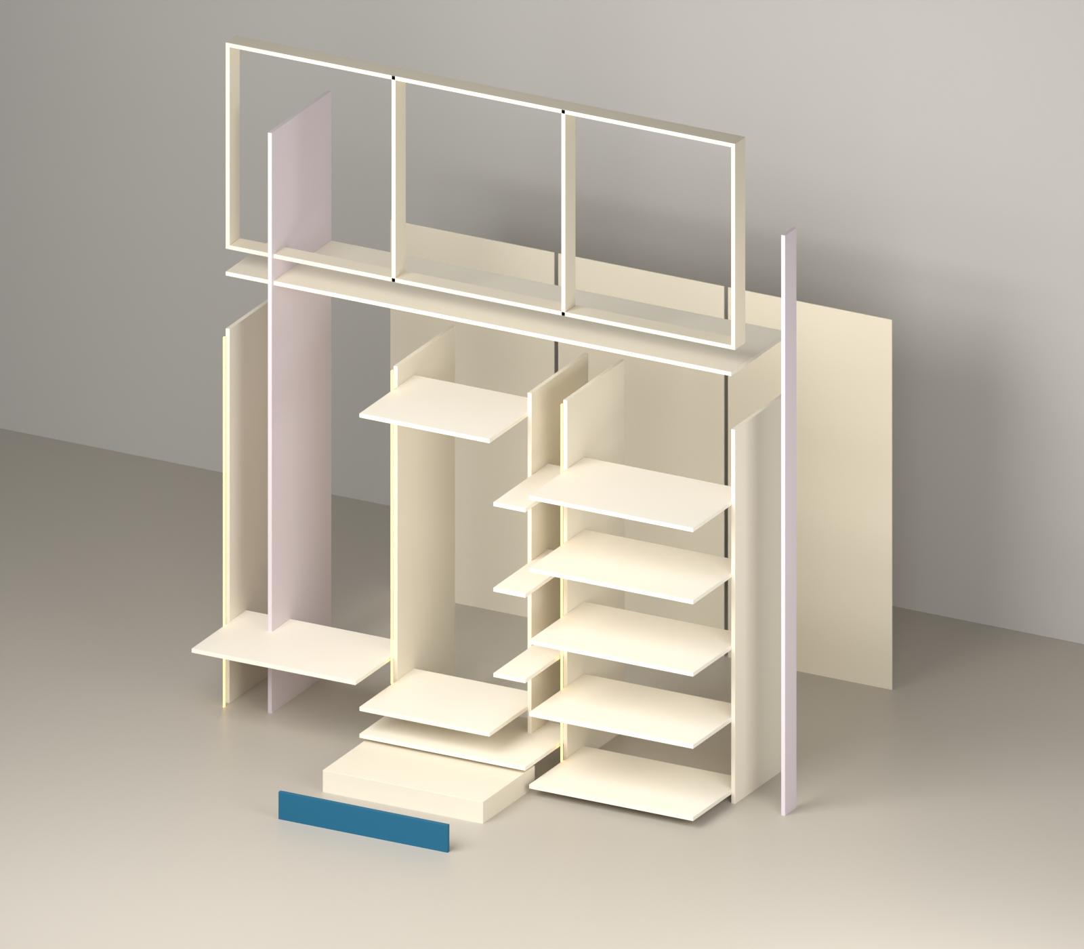

1ST FLOOR M.BEDROOM - cut list
No | Part | Laminate | Qty | Cut L | Cut W | Edge tape | Where / fitting
CARCASS (18 mm, Ivory White)
34 | Bottom panel | Ivory White | 1 | 2331 | 499 | 0.5 mm, 1 long | box bottom
35 | Top panel | Ivory White | 1 | 2331 | 499 | 0.5 mm, 1 long | box top
36 | Side panel (cupboard, 2000 high) | Ivory White | 2 | 2000 | 499 | 0.5 mm, 1 long | box ends; 6 mm back groove inner face; LED groove (see below)
37 | Partition (full height, doors fixed) | Ivory White | 2 | 1884 | 499 | 0.5 mm, 1 long | between sections, doors hinge here; back groove both faces
38 | Partition (inside) | Ivory White | 1 | 1493 | 493 | 0.5 mm, 1 long | dressing / bangle column (stands on shelf, in front of back panel)
LOFT FRAME 90 mm
39 | Top rail | Ivory White | 1 | 2313 | 89 | 0.5 mm, 1 long | loft frame top, fix to ceiling
40 | Bottom rail (front, on cupboard top) | Ivory White | 1 | 2313 | 89 | 0.5 mm, 1 long | loft frame bottom, on cupboard top
41 | Frame upright (end / partition) | Ivory White | 4 | 905 | 89 | 0.5 mm, 1 long | loft frame - at ends and partitions
SHELVES
42 | Shelf | Ivory White | 2 | 765 | 473 | 0.5 mm, 1 long | set back 20 mm from front
43 | Shelf | Ivory White | 6 | 756 | 473 | 0.5 mm, 1 long | set back 20 mm from front
44 | Shelf | Ivory White | 2 | 600 | 473 | 0.5 mm, 1 long | set back 20 mm from front
45 | Shelf | Ivory White | 3 | 147 | 473 | 0.5 mm, 1 long | set back 20 mm from front
BACK PANELS 6 mm
46 | Main back panel | Ivory White 1 side | 1 | 1896 | 777 | - | slides in 6 mm groove (sides / partitions / top / bottom)
47 | Main back panel | Ivory White 1 side | 2 | 1896 | 768 | - | slides in 6 mm groove (sides / partitions / top / bottom)
DRAWER BOX
48 | drawer front/back inner | Ivory White | 4 | 703 | 149 | 0.5 mm, 1 long | groove for bottom: leave 12, 8 W x 10 D
49 | drawer side | Ivory White | 4 | 450 | 149 | 0.5 mm, 1 long | groove for bottom: leave 12, 8 W x 10 D
50 | drawer bottom 6 mm (in groove) | Ivory White 1 side | 2 | 432 | 721 | - | slides in the 10 mm groove
SHUTTERS / COVER / SKIRTING (colour laminate + backer)
51 | Skirting (front, base 80) | 27292 LV Mink | 1 | 2349 | 79 | 0.5 mm, 1 long | front of base 80
52 | Side cover panel - lower (floor to 2000) | 27292 LV Mink | 1 | 2000 | 516 | 2 mm, 1 long | LEFT end, 518 deep (flush with door front); joint at 2000
53 | Wall-side strip 100 - lower (floor to 2000) | 27292 LV Mink | 1 | 2000 | 98 | 2 mm, 1 long | RIGHT end at front, flush with doors; joint at 2000
54 | Door (full height) | 27292 LV Mink | 2 | 1914 | 384 | 2 mm, 4 sides | 5 hinges each
55 | Door (full height) | 27262 LV Peacock | 2 | 1914 | 384 | 2 mm, 4 sides | 5 hinges each
56 | Door above drawers | 27292 LV Mink | 2 | 1514 | 384 | 2 mm, 4 sides | doors above the drawers; 4 hinges
57 | Side cover panel - upper (loft) | 27292 LV Mink | 1 | 905 | 516 | 2 mm, 1 long | LEFT end, 518 deep (flush with door front); joint at 2000
58 | Wall-side strip 100 - upper (loft) | 27292 LV Mink | 1 | 905 | 98 | 2 mm, 1 long | RIGHT end at front, flush with doors; joint at 2000
59 | Loft door | 27292 LV Mink | 6 | 899 | 384 | 2 mm, 4 sides | on loft frame; same width as door below
60 | Drawer outside front | 27262 LV Peacock | 2 | 774 | 194 | 2 mm, 4 sides | screw to drawer box front; handle

Hardware
- LED strip light + aluminium profile (in grooves): 3 pcs, 5.08 m total
- LED driver + door sensor switch: 1
- Soft-close telescopic channels 450 mm (pairs): 2
- Drawer handles / profile: 2
- Concealed soft-close hinges (doors): 46
- Door handles: 6
LED groove (12 W x 8 D, 100 mm from front)
- Section 1 (756 wide): Side panel, right face - start 0 mm, groove 1884 mm, LED strip 1864 mm
- Section 2 (765 wide): Partition, right face - start 509 mm, groove 1375 mm, LED strip 1355 mm
- Section 3 (756 wide): Partition, right face - start 0 mm, groove 1884 mm, LED strip 1864 mm

1ST FLOOR BEDROOM 2 - 2D
Box 2319 W x 2895 H x 500 D | with side cover (right) + 100 strip = 2355 W
2D drawing - inside, measurements
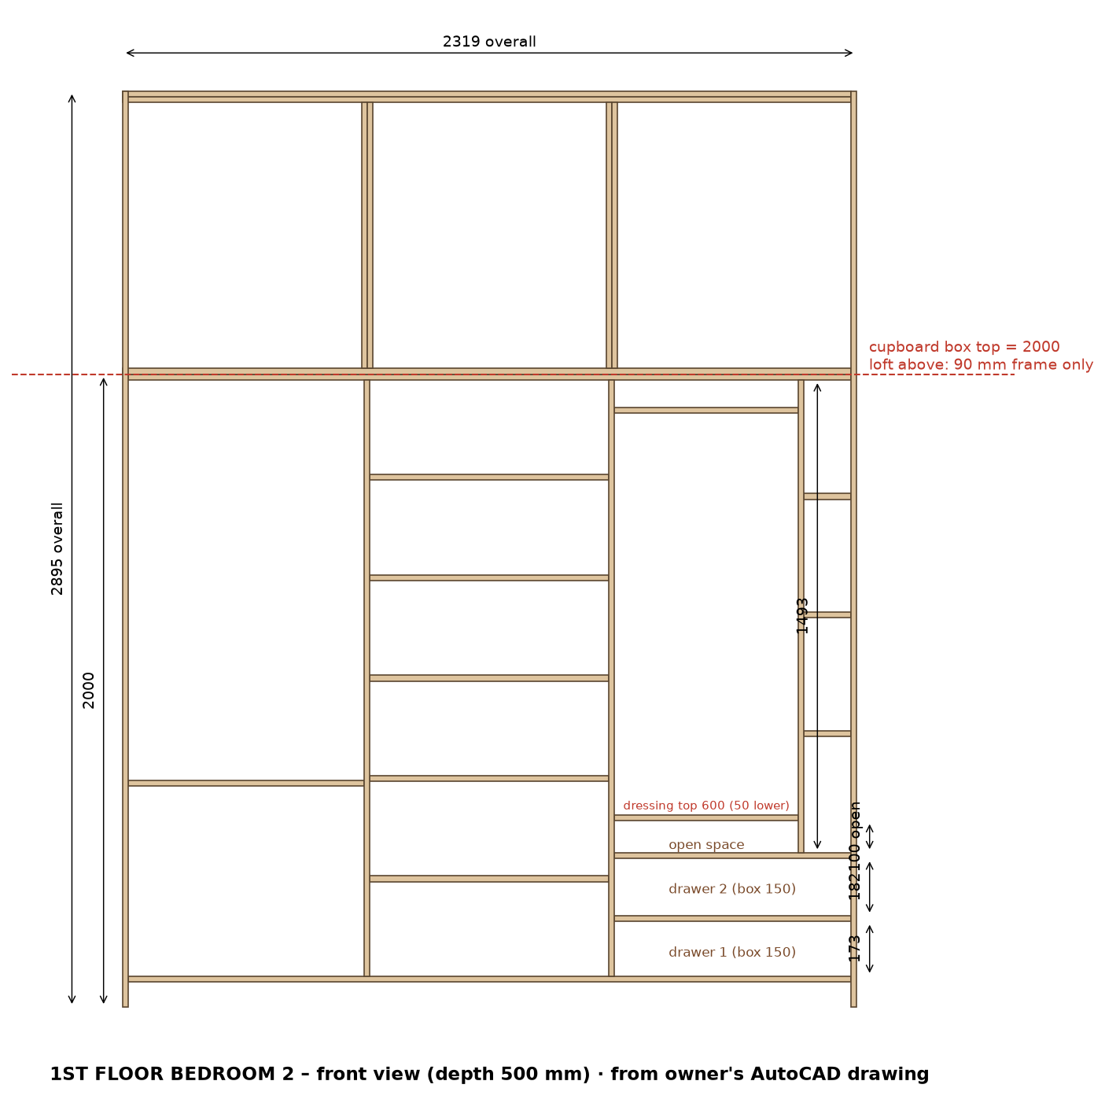
2D shutters - laminate code and size on each door
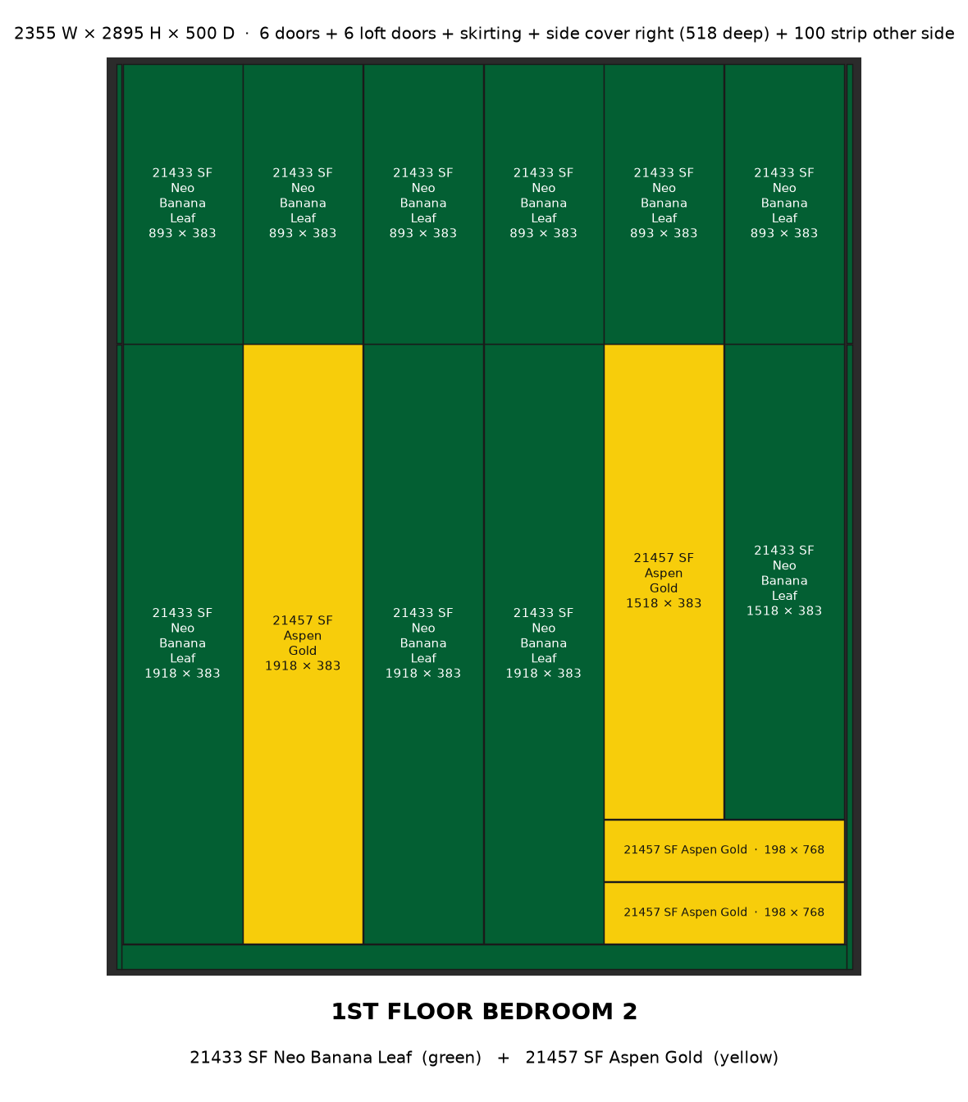

1ST FLOOR BEDROOM 2 - 3D
3D - assembled box, without doors
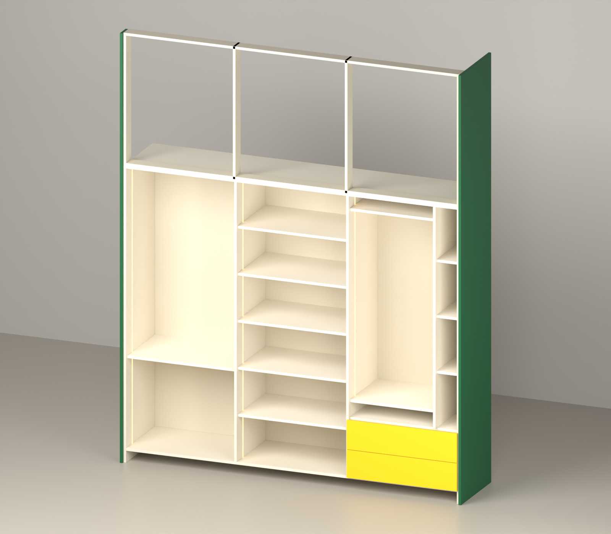
3D - exploded pieces
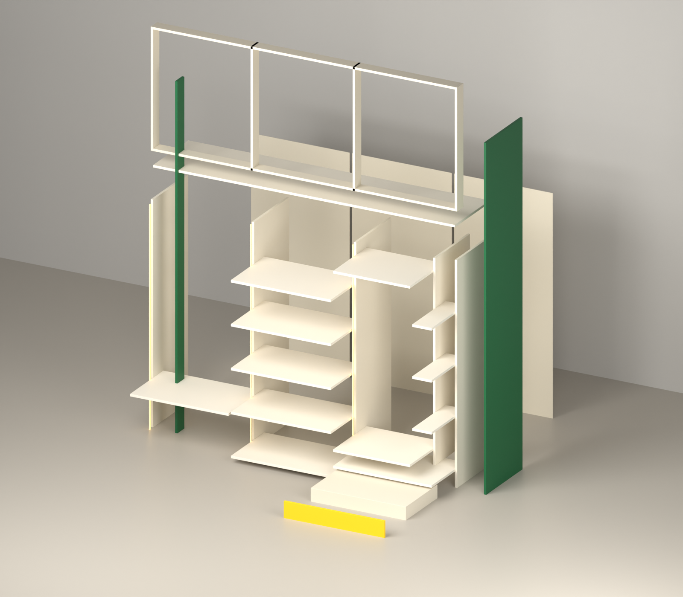

1ST FLOOR BEDROOM 2 - cut list
No | Part | Laminate | Qty | Cut L | Cut W | Edge tape | Where / fitting
CARCASS (18 mm, Ivory White)
61 | Bottom panel | Ivory White | 1 | 2283 | 499 | 0.5 mm, 1 long | box bottom
62 | Top panel | Ivory White | 1 | 2283 | 499 | 0.5 mm, 1 long | box top
63 | Side panel (cupboard, 2000 high) | Ivory White | 2 | 2000 | 499 | 0.5 mm, 1 long | box ends; 6 mm back groove inner face; LED groove (see below)
64 | Partition (full height, doors fixed) | Ivory White | 2 | 1884 | 499 | 0.5 mm, 1 long | between sections, doors hinge here; back groove both faces
65 | Partition (inside) | Ivory White | 1 | 1493 | 493 | 0.5 mm, 1 long | dressing / bangle column (stands on shelf, in front of back panel)
LOFT FRAME 90 mm
66 | Top rail | Ivory White | 1 | 2283 | 89 | 0.5 mm, 1 long | loft frame top, fix to ceiling
67 | Bottom rail (front, on cupboard top) | Ivory White | 1 | 2283 | 89 | 0.5 mm, 1 long | loft frame bottom, on cupboard top
68 | Frame upright (end / partition) | Ivory White | 4 | 895 | 89 | 0.5 mm, 1 long | loft frame - at ends and partitions
SHELVES
69 | Shelf | Ivory White | 5 | 755 | 473 | 0.5 mm, 1 long | set back 20 mm from front
70 | Shelf | Ivory White | 3 | 746 | 473 | 0.5 mm, 1 long | set back 20 mm from front
71 | Shelf | Ivory White | 2 | 581 | 473 | 0.5 mm, 1 long | set back 20 mm from front
72 | Shelf | Ivory White | 3 | 147 | 473 | 0.5 mm, 1 long | set back 20 mm from front
BACK PANELS 6 mm
73 | Main back panel | Ivory White 1 side | 1 | 1896 | 767 | - | slides in 6 mm groove (sides / partitions / top / bottom)
74 | Main back panel | Ivory White 1 side | 2 | 1896 | 758 | - | slides in 6 mm groove (sides / partitions / top / bottom)
DRAWER BOX
75 | drawer front/back inner | Ivory White | 4 | 684 | 149 | 0.5 mm, 1 long | groove for bottom: leave 12, 8 W x 10 D
76 | drawer side | Ivory White | 4 | 450 | 149 | 0.5 mm, 1 long | groove for bottom: leave 12, 8 W x 10 D
77 | drawer bottom 6 mm (in groove) | Ivory White 1 side | 2 | 432 | 702 | - | slides in the 10 mm groove
SHUTTERS / COVER / SKIRTING (colour laminate + backer)
78 | Skirting (front, base 80) | 21433 SF Neo Banana Leaf | 1 | 2319 | 79 | 0.5 mm, 1 long | front of base 80
79 | Side cover panel - lower (floor to 2000) | 21433 SF Neo Banana Leaf | 1 | 2000 | 516 | 2 mm, 1 long | RIGHT end, 518 deep (flush with door front); joint at 2000
80 | Wall-side strip 100 - lower (floor to 2000) | 21433 SF Neo Banana Leaf | 1 | 2000 | 98 | 2 mm, 1 long | LEFT end at front, flush with doors; joint at 2000
81 | Door (full height) | 21433 SF Neo Banana Leaf | 3 | 1914 | 379 | 2 mm, 4 sides | 5 hinges each
82 | Door (full height) | 21457 SF Aspen Gold | 1 | 1914 | 379 | 2 mm, 4 sides | 5 hinges each
83 | Door above drawers | 21457 SF Aspen Gold | 1 | 1514 | 379 | 2 mm, 4 sides | doors above the drawers; 4 hinges
84 | Door above drawers | 21433 SF Neo Banana Leaf | 1 | 1514 | 379 | 2 mm, 4 sides | doors above the drawers; 4 hinges
85 | Side cover panel - upper (loft) | 21433 SF Neo Banana Leaf | 1 | 895 | 516 | 2 mm, 1 long | RIGHT end, 518 deep (flush with door front); joint at 2000
86 | Wall-side strip 100 - upper (loft) | 21433 SF Neo Banana Leaf | 1 | 895 | 98 | 2 mm, 1 long | LEFT end at front, flush with doors; joint at 2000
87 | Loft door | 21433 SF Neo Banana Leaf | 6 | 889 | 379 | 2 mm, 4 sides | on loft frame; same width as door below
88 | Drawer outside front | 21457 SF Aspen Gold | 2 | 764 | 194 | 2 mm, 4 sides | screw to drawer box front; handle

Hardware
- LED strip light + aluminium profile (in grooves): 3 pcs, 5.08 m total
- LED driver + door sensor switch: 1
- Soft-close telescopic channels 450 mm (pairs): 2
- Drawer handles / profile: 2
- Concealed soft-close hinges (doors): 40
- Door handles: 6
LED groove (12 W x 8 D, 100 mm from front)
- Section 1 (746 wide): Side panel, right face - start 0 mm, groove 1884 mm, LED strip 1864 mm
- Section 2 (755 wide): Partition, right face - start 0 mm, groove 1884 mm, LED strip 1864 mm
- Section 3 (746 wide): Partition, right face - start 509 mm, groove 1375 mm, LED strip 1355 mm

2ND FLOOR BEDROOM - 2D
Box 2349 W x 2825 H x 500 D | with side cover (left) + 100 strip = 2385 W
2D drawing - inside, measurements
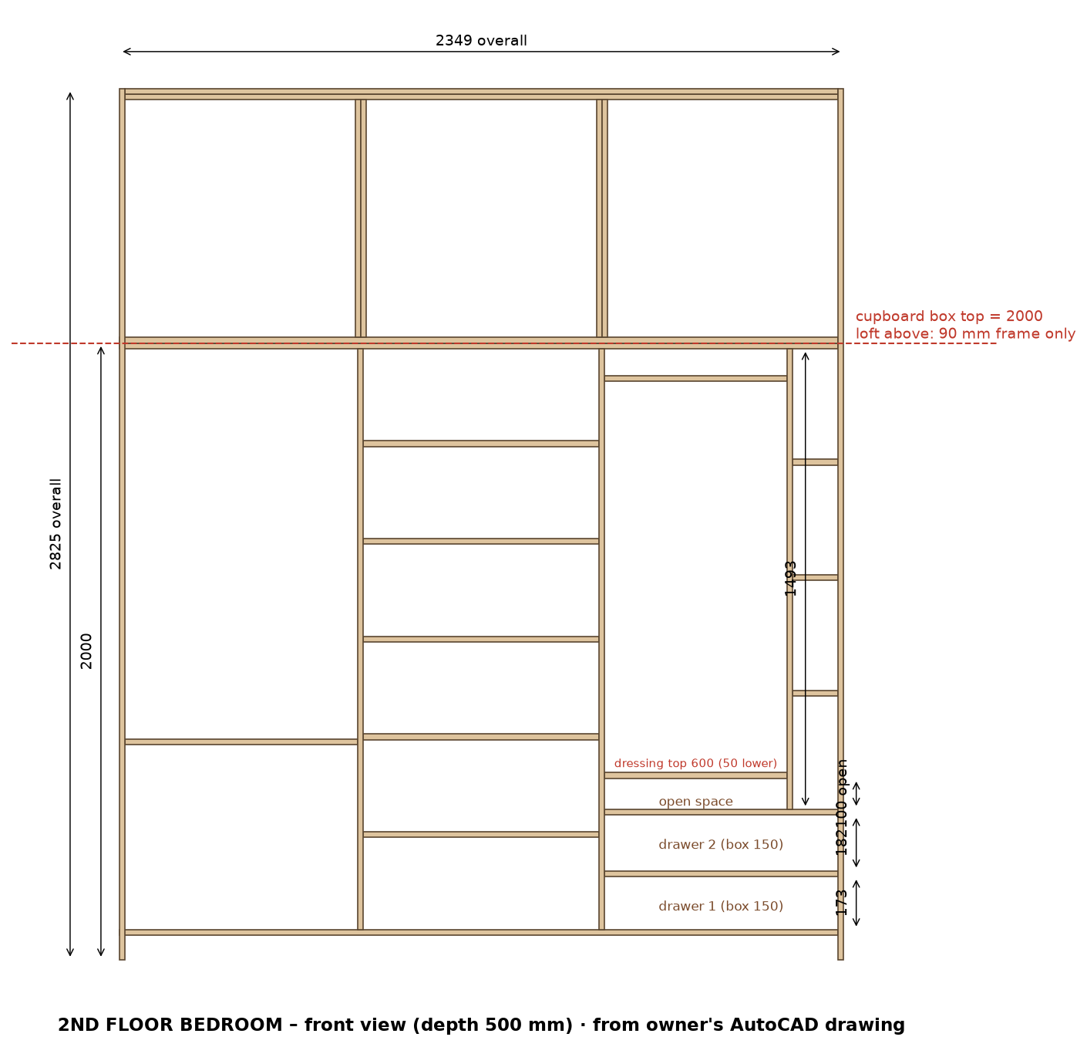
2D shutters - laminate code and size on each door
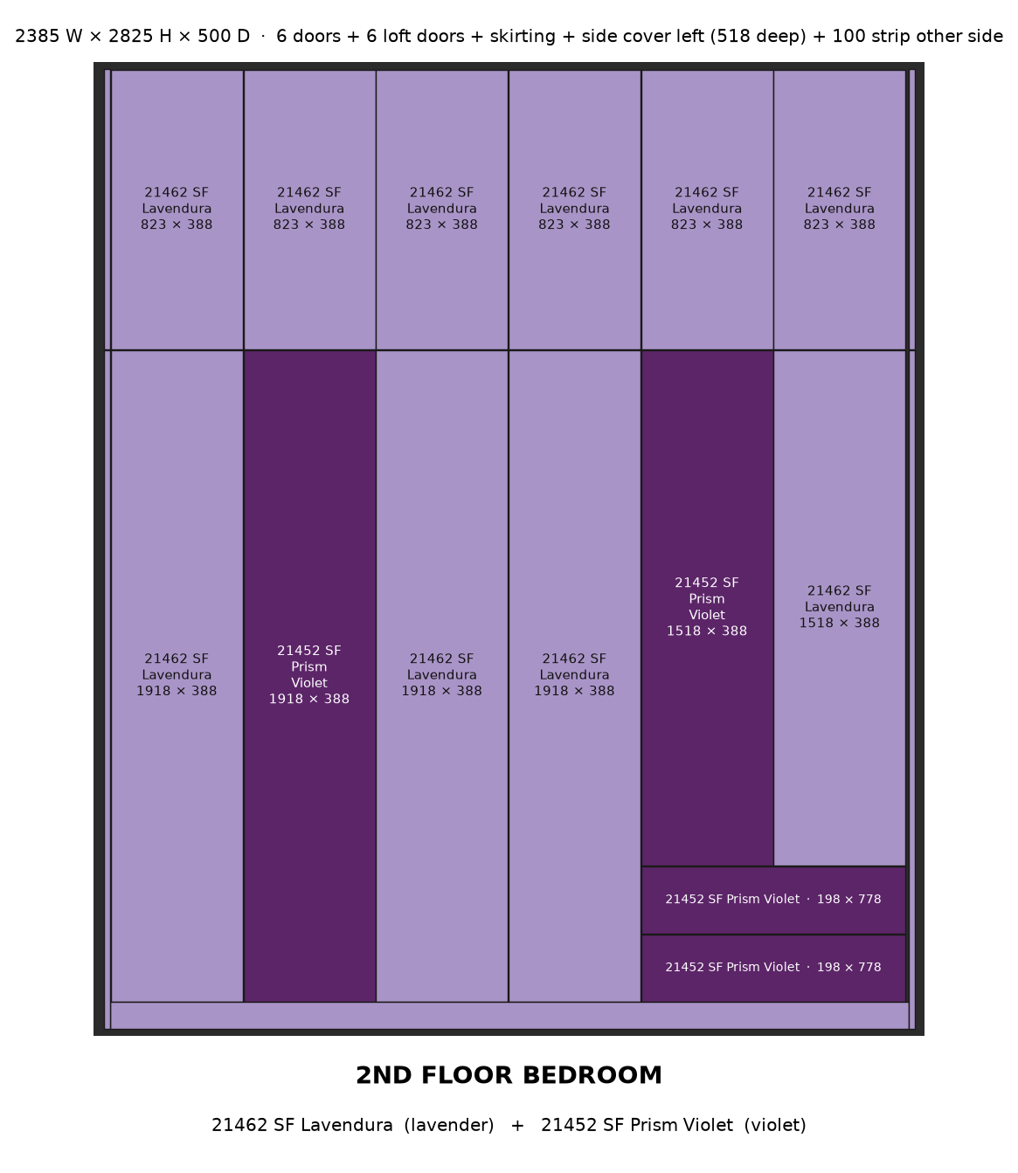

2ND FLOOR BEDROOM - 3D
3D - assembled box, without doors
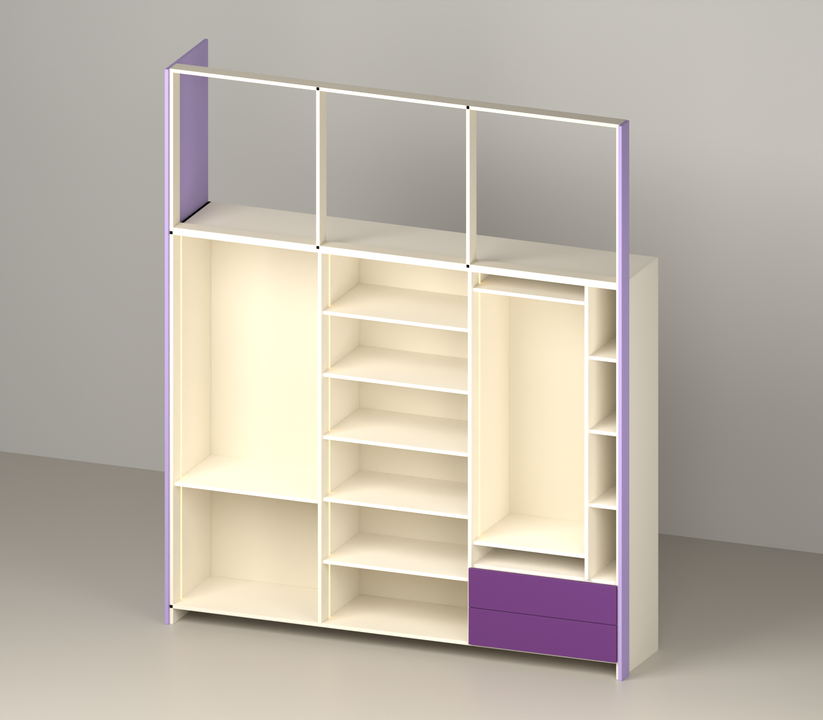
3D - exploded pieces
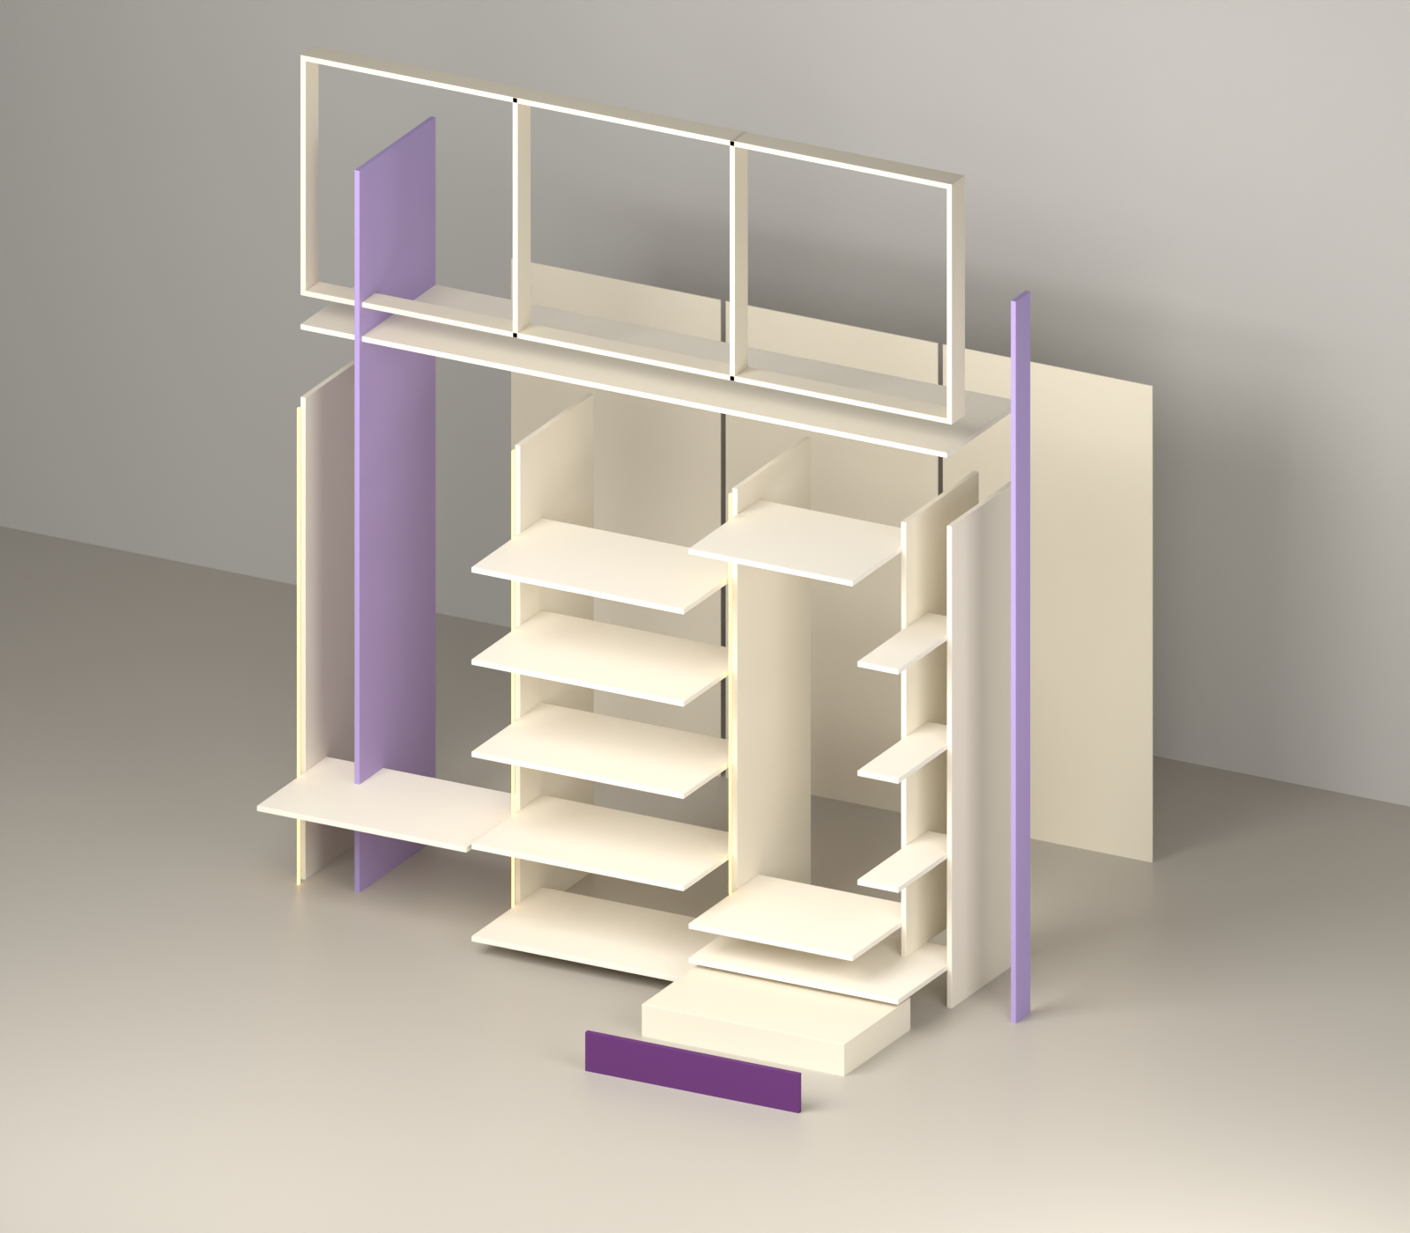

2ND FLOOR BEDROOM - cut list
No | Part | Laminate | Qty | Cut L | Cut W | Edge tape | Where / fitting
CARCASS (18 mm, Ivory White)
89 | Bottom panel | Ivory White | 1 | 2331 | 499 | 0.5 mm, 1 long | box bottom
90 | Top panel | Ivory White | 1 | 2331 | 499 | 0.5 mm, 1 long | box top
91 | Side panel (cupboard, 2000 high) | Ivory White | 2 | 2000 | 499 | 0.5 mm, 1 long | box ends; 6 mm back groove inner face; LED groove (see below)
92 | Partition (full height, doors fixed) | Ivory White | 2 | 1884 | 499 | 0.5 mm, 1 long | between sections, doors hinge here; back groove both faces
93 | Partition (inside) | Ivory White | 1 | 1493 | 493 | 0.5 mm, 1 long | dressing / bangle column (stands on shelf, in front of back panel)
LOFT FRAME 90 mm
94 | Top rail | Ivory White | 1 | 2313 | 89 | 0.5 mm, 1 long | loft frame top, fix to ceiling
95 | Bottom rail (front, on cupboard top) | Ivory White | 1 | 2313 | 89 | 0.5 mm, 1 long | loft frame bottom, on cupboard top
96 | Frame upright (end / partition) | Ivory White | 4 | 825 | 89 | 0.5 mm, 1 long | loft frame - at ends and partitions
SHELVES
97 | Shelf | Ivory White | 5 | 765 | 473 | 0.5 mm, 1 long | set back 20 mm from front
98 | Shelf | Ivory White | 3 | 756 | 473 | 0.5 mm, 1 long | set back 20 mm from front
99 | Shelf | Ivory White | 2 | 591 | 473 | 0.5 mm, 1 long | set back 20 mm from front
100 | Shelf | Ivory White | 3 | 147 | 473 | 0.5 mm, 1 long | set back 20 mm from front
BACK PANELS 6 mm
101 | Main back panel | Ivory White 1 side | 1 | 1896 | 777 | - | slides in 6 mm groove (sides / partitions / top / bottom)
102 | Main back panel | Ivory White 1 side | 2 | 1896 | 768 | - | slides in 6 mm groove (sides / partitions / top / bottom)
DRAWER BOX
103 | drawer front/back inner | Ivory White | 4 | 694 | 149 | 0.5 mm, 1 long | groove for bottom: leave 12, 8 W x 10 D
104 | drawer side | Ivory White | 4 | 450 | 149 | 0.5 mm, 1 long | groove for bottom: leave 12, 8 W x 10 D
105 | drawer bottom 6 mm (in groove) | Ivory White 1 side | 2 | 432 | 712 | - | slides in the 10 mm groove
SHUTTERS / COVER / SKIRTING (colour laminate + backer)
106 | Skirting (front, base 80) | 21462 SF Lavendura | 1 | 2349 | 79 | 0.5 mm, 1 long | front of base 80
107 | Side cover panel - lower (floor to 2000) | 21462 SF Lavendura | 1 | 2000 | 516 | 2 mm, 1 long | LEFT end, 518 deep (flush with door front); joint at 2000
108 | Wall-side strip 100 - lower (floor to 2000) | 21462 SF Lavendura | 1 | 2000 | 98 | 2 mm, 1 long | RIGHT end at front, flush with doors; joint at 2000
109 | Door (full height) | 21462 SF Lavendura | 3 | 1914 | 384 | 2 mm, 4 sides | 5 hinges each
110 | Door (full height) | 21452 SF Prism Violet | 1 | 1914 | 384 | 2 mm, 4 sides | 5 hinges each
111 | Door above drawers | 21452 SF Prism Violet | 1 | 1514 | 384 | 2 mm, 4 sides | doors above the drawers; 4 hinges
112 | Door above drawers | 21462 SF Lavendura | 1 | 1514 | 384 | 2 mm, 4 sides | doors above the drawers; 4 hinges
113 | Side cover panel - upper (loft) | 21462 SF Lavendura | 1 | 825 | 516 | 2 mm, 1 long | LEFT end, 518 deep (flush with door front); joint at 2000
114 | Wall-side strip 100 - upper (loft) | 21462 SF Lavendura | 1 | 825 | 98 | 2 mm, 1 long | RIGHT end at front, flush with doors; joint at 2000
115 | Loft door | 21462 SF Lavendura | 6 | 819 | 384 | 2 mm, 4 sides | on loft frame; same width as door below
116 | Drawer outside front | 21452 SF Prism Violet | 2 | 774 | 194 | 2 mm, 4 sides | screw to drawer box front; handle

Hardware
- LED strip light + aluminium profile (in grooves): 3 pcs, 5.08 m total
- LED driver + door sensor switch: 1
- Soft-close telescopic channels 450 mm (pairs): 2
- Drawer handles / profile: 2
- Concealed soft-close hinges (doors): 40
- Door handles: 6
LED groove (12 W x 8 D, 100 mm from front)
- Section 1 (756 wide): Side panel, right face - start 0 mm, groove 1884 mm, LED strip 1864 mm
- Section 2 (765 wide): Partition, right face - start 0 mm, groove 1884 mm, LED strip 1864 mm
- Section 3 (756 wide): Partition, right face - start 509 mm, groove 1375 mm, LED strip 1355 mm

